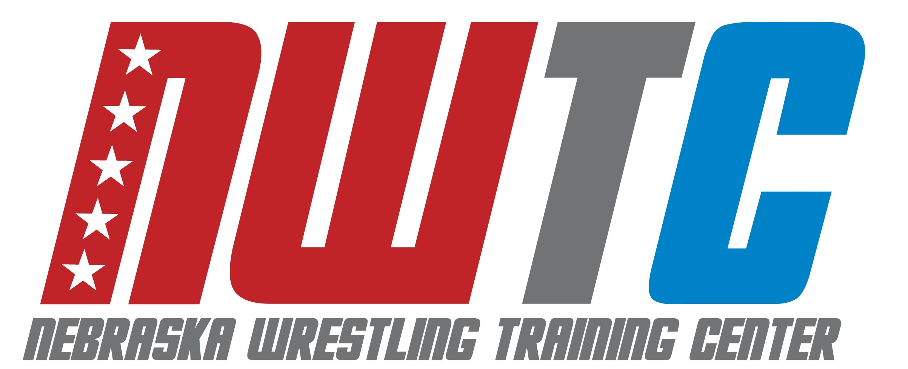

ELITE FREESTYLE CAMP SCHEDULE

**** Meet camp counselor in dorm lobby **30 minutes prior to every session** ****

# MONDAY, June 23

300-430pm Resident check-in, Harper Hall, 1150 N 14th St, Lincoln, NE 68508

645pm Commuter check-in, Hendricks Training Complex, 1600 Court St., Lincoln, NE 68588

700pm Technique: NU Wrestling Room

# TUESDAY, June 24

630-730am Breakfast

1000am Technique: NU Wrestling Room

11-1200pm Lunch

300pm Drill + Live wrestling: NU Track

500-600pm Dinner

700pm Film Review – Dorm Lounge

# WEDNESDAY, June 25

630-730am Breakfast

1000am Technique: NU Wrestling Room

11-1200pm Lunch

300pm Drill + Live Wrestling: NU Track 500-600pm Dinner

700pm Mindset Talk – Dorm Lounge

# THURSDAY, June 26

630-730am Breakfast

1000am Technique: NU Wrestling Room

11-1200pm Lunch

300pm Drill + Live wrestling: NU Track 500-600pm Dinner

700pm Games: Memorial Stadium

# FRIDAY, June 27

630-730am Breakfast

900am Technique: NU Wrestling Room

1030am Check-out